Installation Instructions – Visual Utilization Report

* Go to Admin > Reports
* Click Add Report
* Fill in the Add/Edit Report according to the following:

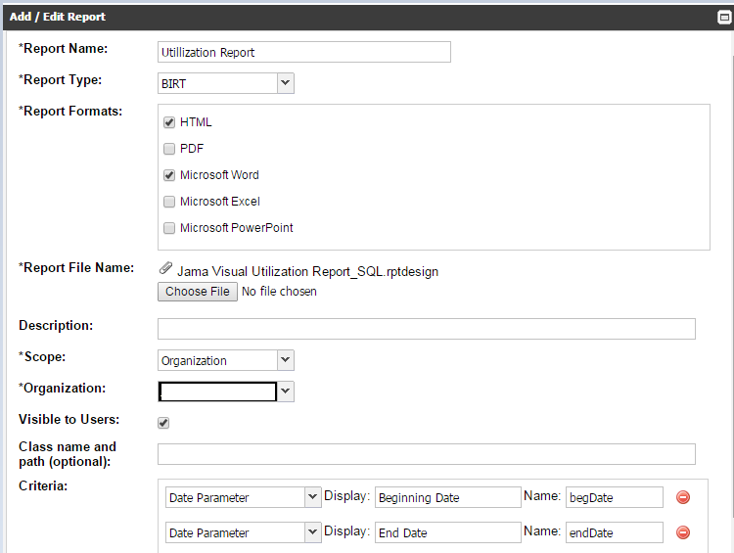

Note: Your Organization field will have a different value.

* Click Save
* Go back to Projects and click on the Reports link
* Run the report